INDEX
SR.NO | PRACTICAL NAME | DATE | TEACHER'S SIGNATURE
1. | Document Indexing and Retrieval
2. | Retrieval Models
3. | Spelling Correction in IR Systems
4. | Evaluation Metrics for IR Systems
5. | Text Categorization
6. | Clustering for Information Retrieval
7. | Web Crawling and Indexing
8. | Link Analysis and PageRank
9. | Learning to Rank
10. | Advanced Topics in Information Retrieval

Practical No: 1

Aim: Document Indexing and Retrieval

document1 = "The quick brown fox jumped over the lazy dog." document2 = "The lazy dog slept in the sun."

tokens1 = document1.lower().split() tokens2 = document2.lower().split() terms = list(set(tokens1 + tokens2)) inverted_index = {} for term in terms: documents = [] if term in tokens1: documents.append("Document 1") if term in tokens2:
documents.append("Document 2") inverted_index[term] = documents for term, documents in inverted_index.items():
print(term, "->", ", ".join(documents))

Output:
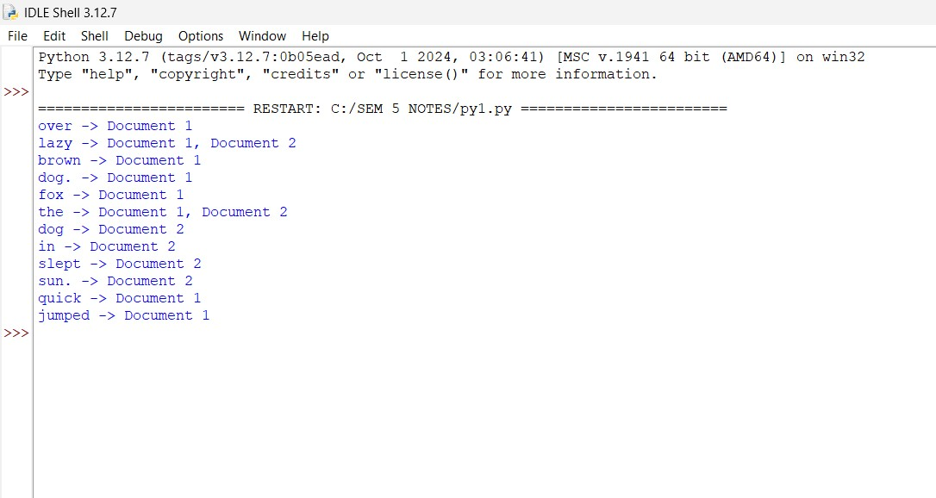

(B) File.txt
file = open('file.txt', encoding='utf8') read=file.read() file.seek(0) print (read) line=1 for word in read: if word =="n":
line+=1
print ("Number of line in files is: ", line) array = [] for i in range (line):
array.append(file.readline())

Output:

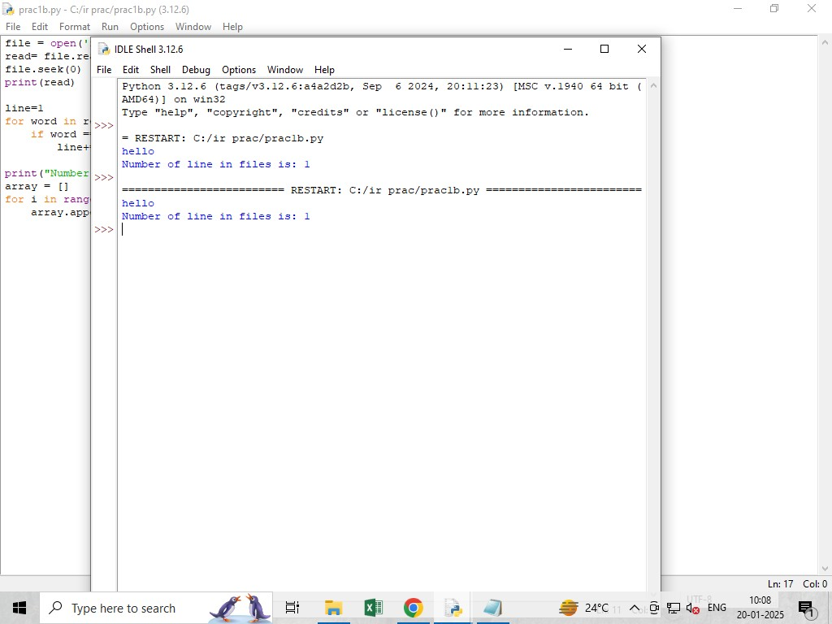

C)
import nltk from nltk.tokenize import word_tokenize from nltk.corpus import stopwords

nltk.download('stopwords') nltk.download('punkt')

text = "This is a simple sentence"

text_tokens = word_tokenize(text)

tokens_without_sw = [word for word in text_tokens if word.lower() not in stopwords.words('english')] print(tokens_without_sw)

Output:

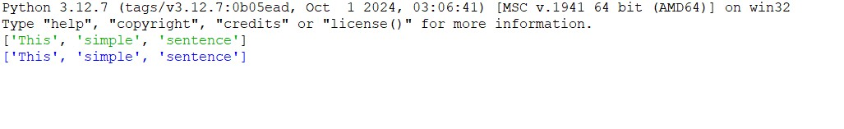

Practical No: 2

A) Implement the Boolean retrieval model and process queries:

documents = {
1: "apple banana orange",
2: "apple banana",
3: "banana orange",
4: "apple"
}
def build_index(docs):
index = {} for doc_id, text in docs.items():
terms = set(text.split()) for term in terms: if term not in index:
index[term] = {doc_id}
else:
index[term].add(doc_id) return index inverted_index = build_index(documents) def boolean_and(operands, index):
if not operands:
return list(range(1, len(documents) + 1)) result = index.get(operands[0], set()) for term in operands[1:]:
result = result.intersection(index.get(term, set())) return list(result)
def boolean_or(operands, index):
result = set()
for term in operands:
result = result.union(index.get(term, set()))
return list(result)
def boolean_not(operand, index, total_docs): operand_set = set(index.get(operand, set())) all_docs_set = set(range(1, total_docs + 1)) return list(all_docs_set.difference(operand_set)) query1 = ["apple", "banana"] query2 = ["apple", "orange"] result1 = boolean_and(query1, inverted_index) result2 = boolean_or(query2, inverted_index) result3 = boolean_not("orange", inverted_index, len(documents)) print("Documents containing 'apple' and 'banana':", result1) print("Documents containing 'apple' or 'orange':", result2) print("Documents not containing 'orange':", result3)

Output:
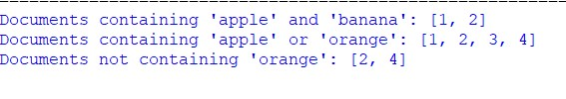

B) Implement the vector space model with TF-IDF weighting and cosine similarity:

from sklearn.feature_extraction.text import CountVectorizer, TfidfTransformer import nltk from nltk.corpus import stopwords import numpy as np from numpy.linalg import norm

train_set = ["The sky is blue.", "The sun is bright."] test_set = ["The sun in the sky is bright."] nltk.download('stopwords')

vectorizer = CountVectorizer(stop_words='english') transformer = TfidfTransformer()

trainVectorizerArray = vectorizer.fit_transform(train_set).toarray() testVectorizerArray = vectorizer.transform(test_set).toarray()

print('Fit Vectorizer to train set:', trainVectorizerArray) print('Transform Vectorizer to test set:', testVectorizerArray)

cosine_similarity = lambda a, b: round(np.inner(a, b) / (norm(a) * norm(b)), 3) if norm(a) * norm(b) != 0 else 0

for i, vector in enumerate(trainVectorizerArray):
print(f"Train Vector {i+1}: {vector}") for testV in testVectorizerArray: print(f"Test Vector: {testV}") cosine = cosine_similarity(vector, testV) print(f"Cosine similarity with Train Document {i+1}: {cosine}")

Output:
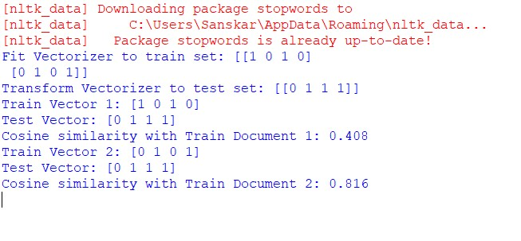

Practical No: 3

A) Develop a spelling correction module using edit distance algorithms.

def editDistance(str1, str2, m, n):
# Base cases if m == 0: return n if n == 0: return m if str1[m - 1] == str2[n - 1]:
return editDistance(str1, str2, m - 1, n - 1) return 1 + min(
editDistance(str1, str2, m, n - 1), editDistance(str1, str2, m - 1, n), editDistance(str1, str2, m - 1, n - 1)
)
str1 = "sunday" str2 = "saturday" print('Edit Distance is:', editDistance(str1, str2, len(str1), len(str2)))

Output:
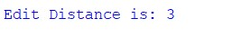

Practical No: 4

A) Calculate precision, recall, and F-measure for a given set of retrieval results.

def calculate_metrics(retrieved_set, relevant_set):
true_positive = len(retrieved_set.intersection(relevant_set)) false_positive = len(retrieved_set.difference(relevant_set)) false_negative = len(relevant_set.difference(retrieved_set)) print("True Positive:", true_positive) print("False Positive:", false_positive) print("False Negative:", false_negative, "\n")

precision = true_positive / (true_positive + false_positive) if (true_positive + false_positive) > 0 else
0 recall = true_positive / (true_positive + false_negative) if (true_positive + false_negative) > 0 else 0 f_measure = (2 * precision * recall / (precision + recall)) if (precision + recall) > 0 else 0 return precision, recall, f_measure retrieved_set = {"doc1", "doc2", "doc3"} relevant_set = {"doc1", "doc4"} precision, recall, f_measure = calculate_metrics(retrieved_set, relevant_set) print(f"Precision: {precision:.2f}") print(f"Recall: {recall:.2f}")
print(f"F-measure: {f_measure:.2f}")

Output:
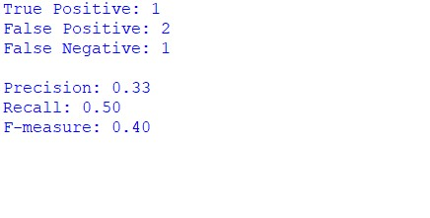

B) Use an evaluation toolkit to measure average precision and other evaluation metrics.

from sklearn.metrics import average_precision_score

y_true = [0, 1, 1, 0, 1, 1]

y_scores = [0.1, 0.4, 0.35, 0.8, 0.65, 0.9]

average_precision = average_precision_score(y_true, y_scores)

print(f"Average Precision-Recall Score: {average_precision:.4f}")

Output:

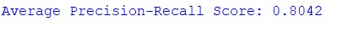

Practical No: 5

A) Implement a text classification algorithm (e.g., Naive Bayes or Support Vector Machines)

import pandas as pd from sklearn.model_selection import train_test_split from sklearn.feature_extraction.text import CountVectorizer from sklearn.naive_bayes import MultinomialNB from sklearn.metrics import accuracy_score, classification_report

# Load dataset df = pd.read_csv(r"C:\Users\Sanskar\OneDrive\Desktop\IR\Dataset.csv")

# Handle missing values and create text features df["Covid"] = df["Covid"].fillna('') df["Fever"] = df["Fever"].fillna('')
X = (df["Covid"] + " " + df["Fever"]).astype(str) # Convert to string to avoid issues y = df["Flu"] # Target variable

# Split data into training and testing sets
X_train, X_test, y_train, y_test = train_test_split(X, y, test_size=0.2, random_state=42)

# Vectorize the text data vectorizer = CountVectorizer()
X_train_counts = vectorizer.fit_transform(X_train)
X_test_counts = vectorizer.transform(X_test)

# Train Naïve Bayes Classifier classifier = MultinomialNB() classifier.fit(X_train_counts, y_train)

# Load test data data1 = pd.read_csv(r"C:\Users\Sanskar\OneDrive\Desktop\IR\Test.csv")

# Handle missing values and preprocess new data data1["Covid"] = data1["Covid"].fillna('') data1["Fever"] = data1["Fever"].fillna('') new_data = (data1["Covid"] + " " + data1["Fever"]).astype(str)

# Transform new data with the same vectorizer new_data_counts = vectorizer.transform(new_data)
# Make predictions predicted_labels = classifier.predict(new_data_counts)
# Print predictions print("Predicted Labels for New Data:\n", predicted_labels)
# Evaluate model performance on test set accuracy = accuracy_score(y_test, classifier.predict(X_test_counts)) print(f"\nModel Accuracy: {accuracy:.2f}") print("\nClassification Report:") print(classification_report(y_test, classifier.predict(X_test_counts)))

Output:
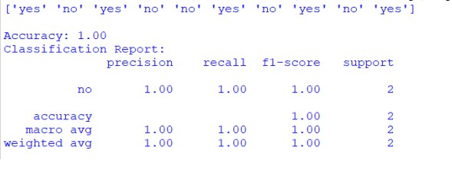

Practical No: 6

Aim: Clustering for Information Retrieval Implement a clustering algorithm (e.g., K-means hierarchical clustering).

from sklearn.feature_extraction.text import TfidfVectorizer from sklearn.cluster import KMeans documents = [
"Cats are known for their agility and grace.",
"Dogs are often called ‘man’s best friend’.",
"Some dogs are trained to assist people with disabilities.",
"The sun rises in the east and sets in the west.",
"Many cats enjoy climbing trees and chasing toys."
]
vectorizer = TfidfVectorizer(stop_words='english') X = vectorizer.fit_transform(documents) kmeans = KMeans(n_clusters=3, random_state=0, n_init='auto').fit(X) print("Cluster assignments:", kmeans.labels_)

Output:

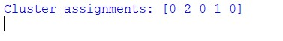

Practical No: 7

A) Develop a web crawler to fetch and index web pages.

import requests from bs4 import BeautifulSoup import time from urllib.parse import urljoin, urlparse from urllib.robotparser import RobotFileParser

def get_html(url):
headers = {'User-Agent': 'Mozilla/5.0 (Windows NT 10.0; Win64; x64) AppleWebKit/537.36
(KHTML, like Gecko) Chrome/58.0.3029.110 Safari/537.3'}
try:
response = requests.get(url, headers=headers) response.raise_for_status() return response.text except requests.exceptions.HTTPError as errh:
print(f"HTTP Error: {errh}")
except requests.exceptions.RequestException as err:
print(f"Request Error: {err}") return None

def save_robots_txt(url):
try:
robots_url = urljoin(url, '/robots.txt') robots_content = get_html(robots_url) if robots_content: with open('robots.txt', 'w', encoding='utf-8') as file:
file.write(robots_content) except Exception as e: print(f"Error saving robots.txt: {e}")

def load_robots_txt():
try: with open('robots.txt', 'r', encoding='utf-8') as file:
return file.readlines() except FileNotFoundError:
return None

def extract_links(html, base_url):
soup = BeautifulSoup(html, 'html.parser')
links = []
for link in soup.find_all('a', href=True):
absolute_url = urljoin(base_url, link.get('href')) links.append(absolute_url) return links

def is_allowed_by_robots(url, robots_content):
parser = RobotFileParser() parser.parse(robots_content) return parser.can_fetch('*', url)

def crawl(start_url, max_depth=3, delay=1):
visited_urls = set()

def recursive_crawl(url, depth, robots_content):
if depth > max_depth or url in visited_urls or (robots_content and not is_allowed_by_robots(url, robots_content)):
return

visited_urls.add(url)
time.sleep(delay)

html = get_html(url)
if html:
print(f"Crawling: {url}") links = extract_links(html, url) for link in links:
recursive_crawl(link, depth + 1, robots_content)

# Save and load robots.txt save_robots_txt(start_url) robots_content = load_robots_txt()

if not robots_content:
print("Unable to retrieve robots.txt. Crawling without restrictions.")

recursive_crawl(start_url, 1, robots_content) print("Crawl completed by 740_Pallavi & 743_Deepak")

crawl('https://wikipedia.com', max_depth=2, delay=2)

Output:
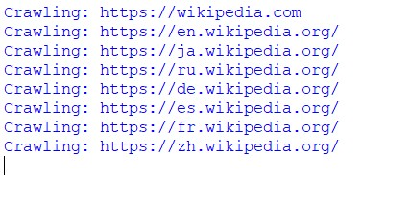

Practical No:8

A) Implement the PageRank algorithm to rank web pages based on link analysis.

import numpy as np def create_adjacency_matrix(links, num_pages): """Create a transition matrix based on link structure.""" adjacency_matrix = np.zeros((num_pages, num_pages))

for i, outgoing_links in links.items(): if outgoing_links:
adjacency_matrix[i, outgoing_links] = 1 / len(outgoing_links)

return adjacency_matrix

def pagerank(links, alpha=0.85, tol=1.0e-6, max_iter=100): """Compute PageRank scores using the power iteration method.""" num_pages = len(links) adjacency_matrix = create_adjacency_matrix(links, num_pages)

ranks = np.ones(num_pages) / num_pages

teleport = np.ones(num_pages) / num_pages

for iteration in range(max_iter):
new_ranks = alpha * adjacency_matrix.T @ ranks + (1 - alpha) * teleport

if np.linalg.norm(new_ranks - ranks, ord=1) < tol:
break

ranks = new_ranks

return ranks

web_graph = {
0: [1, 2],
1: [2],
2: [0],
3: [2]
}

page_ranks = pagerank(web_graph)

print("PageRank Scores:") for i, rank in enumerate(page_ranks): print(f"Page {i}: {rank:.4f}")

Output:

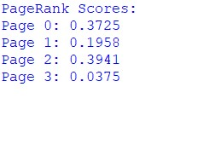

B) Apply the PageRank algorithm to a small web graph and analyse the results

import networkx as nx

G = nx.DiGraph()

G.add_edges_from([('A', 'B'), ('A', 'C'), ('B', 'C'), ('C', 'A'), ('C', 'B')])

pagerank_scores = nx.pagerank(G, alpha=0.85)

for node, score in pagerank_scores.items():
print(f"Node {node} has a PageRank score of {score:.4f}")

Output:

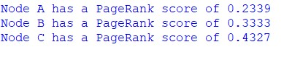

Practical No.9

(A) Implement a learning to rank algorithm

import numpy as np from sklearn.feature_extraction.text import TfidfVectorizer from sklearn.linear_model import LinearRegression from sklearn.model_selection import train_test_split from sklearn.metrics import mean_squared_error queries = [
"best programming languages",
"machine learning tutorials",
"artificial intelligence books"
]
documents = [
"Python is a versatile language used for machine learning and web development.",
"This guide teaches machine learning using scikit-learn and TensorFlow.",
"AI books are essential for learning deep learning techniques and neural networks.",
"Java is widely used for enterprise applications and Android development.",
"Books on AI cover topics from basic to advanced deep learning algorithms."
]
relevance_scores = [
[3, 5, 2, 1, 4],
[4, 5, 3, 2, 1], [5, 4, 3, 1, 2]
]
vectorizer = TfidfVectorizer(stop_words='english')
X_documents = vectorizer.fit_transform(documents) X_query_doc = []
y = []

for query_idx, query in enumerate(queries):
query_vector = vectorizer.transform([query]).toarray()[0]

for doc_idx in range(len(documents)):
doc_vector = X_documents[doc_idx].toarray()[0]

combined_features = np.concatenate([query_vector, doc_vector])
X_query_doc.append(combined_features)

y.append(relevance_scores[query_idx][doc_idx])

X_query_doc = np.array(X_query_doc)
y = np.array(y)

X_train, X_test, y_train, y_test = train_test_split(X_query_doc, y, test_size=0.2, random_state=42)

model = LinearRegression() model.fit(X_train, y_train)

y_pred = model.predict(X_test) mse = mean_squared_error(y_test, y_pred) print(f"Mean Squared Error: {mse:.4f}") print("Predicted Relevance Scores:", y_pred)

Output:

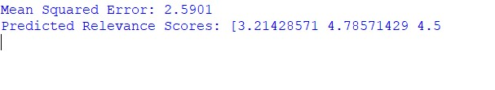

(B) Train the ranking model using labelled data and evaluate its effectiveness

import numpy as np import pandas as pd from sklearn.model_selection import train_test_split from sklearn.ensemble import GradientBoostingRegressor from sklearn.metrics import mean_squared_error, ndcg_score

data = {
'doc_length': [100, 200, 150, 80, 120, 220, 90, 300, 250, 180],
'keyword_freq': [10, 15, 8, 5, 9, 18, 4, 20, 14, 10],
'avg_sentence_length': [10, 15, 12, 8, 9, 20, 7, 25, 18, 16],
'relevance': [2, 3, 1, 0, 1, 3, 0, 3, 2, 2]
}

df = pd.DataFrame(data)

X = df[['doc_length', 'keyword_freq', 'avg_sentence_length']] y = df['relevance']

X_train, X_test, y_train, y_test = train_test_split(X, y, test_size=0.2, random_state=42)

model = GradientBoostingRegressor(n_estimators=100, learning_rate=0.1, max_depth=3)
model.fit(X_train, y_train)

y_pred = model.predict(X_test)

mse = mean_squared_error(y_test, y_pred) print(f"Mean Squared Error: {mse:.4f}") y_true = np.array([
[3, 2, 1, 0], [2, 1, 0, 0]
])

y_pred_reshaped = np.array([
[0.9, 0.8, 0.3, 0.1], [0.7, 0.4, 0.2, 0.1]
])
ndcg = ndcg_score(y_true, y_pred_reshaped) print(f"NDCG Score: {ndcg:.4f}")
def mean_reciprocal_rank(y_true, y_pred): """Calculate MRR score for ranking evaluation."""
mrr = 0 for true_rel, pred_scores in zip(y_true, y_pred): ranked_indices = np.argsort(pred_scores)[::-1]
for i, idx in enumerate(ranked_indices): if true_rel[idx] > 0: mrr += 1 / (i + 1) break
return mrr / len(y_true)
mrr_score = mean_reciprocal_rank(y_true, y_pred_reshaped) print(f"MRR Score: {mrr_score:.4f}")

Output:

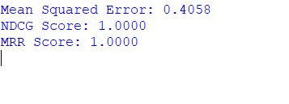

Practical No.10

Aim:- Advanced Topics in Information Retrieval

import nltk from sklearn.feature_extraction.text import TfidfVectorizer from nltk.tokenize import sent_tokenize import heapq

nltk.download('punkt')

def summarize_text(text, summary_length=3):
sentences = sent_tokenize(text)

vectorizer = TfidfVectorizer(stop_words='english') tfidf_matrix = vectorizer.fit_transform(sentences)

sentence_scores = {} for i in range(len(sentences)):
sentence_scores[i] = tfidf_matrix[i].sum()

ranked_sentences = heapq.nlargest(summary_length, sentence_scores, key=sentence_scores.get) ranked_sentences = sorted(ranked_sentences)

summary = [sentences[i] for i in ranked_sentences] return ' '.join(summary)

text = """
Natural language processing (NLP) is a subfield of linguistics, computer science, and artificial intelligence concerned with the interactions between computers and human (natural) languages,
and, in particular, concerned with programming computers to fruitfully process large natural language data.
Challenges in natural language processing frequently involve natural language understanding, natural language generation frequently from formal, machinereadable logical forms),
connecting language and machine perception, managing or analyzing large amounts of unstructured data (such as 'big data'), and often statistical machine learning. """

summary = summarize_text(text) print("Summary:\n", summary)

Output:

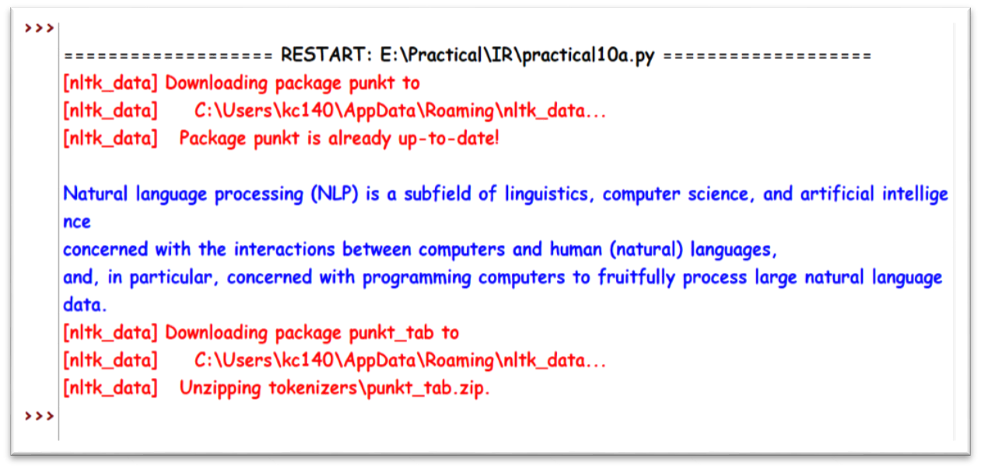

(B) Build a Question-Answering system using technique such as Information Extraction

import nltk import spacy import re from sklearn.feature_extraction.text import TfidfVectorizer from sklearn.metrics.pairwise import cosine_similarity from nltk.tokenize import sent_tokenize

nltk.download('punkt')

nlp = spacy.load("en_core_web_sm")

def preprocess_text(text): return sent_tokenize(text)

def extract_relevant_sentences(text, question, top_n=3):
sentences = preprocess_text(text) if not sentences:
return []

vectorizer = TfidfVectorizer(stop_words='english') tfidf_matrix = vectorizer.fit_transform([question] + sentences)

cosine_similarities = cosine_similarity(tfidf_matrix[0:1], tfidf_matrix[1:]).flatten() relevant_sentences_idx = cosine_similarities.argsort()[-top_n:][::-1] # Fixed indexing

return [sentences[i] for i in relevant_sentences_idx]

def extract_entities(text):
doc = nlp(text) return [(ent.text, ent.label_) for ent in doc.ents]

def extract_answer_from_sentence(sentence, question): if "who" in question.lower():
entities = extract_entities(sentence) for entity, label in entities: if label == "PERSON":
return entity elif "what" in question.lower():
words = re.findall(r'\b\w+\b', sentence) return " ".join(words[:5]) return None

def answer_question(text, question, top_n=3):
relevant_sentences = extract_relevant_sentences(text, question, top_n)

for sentence in relevant_sentences:
answer = extract_answer_from_sentence(sentence, question)
if answer:
return answer return "Sorry, I couldn't find an answer."

text = """
Albert Einstein was born in Ulm, Germany, in 1879. He was a theoretical physicist who developed the theory of relativity.
Einstein is also known for his famous equation, E = mc^2. He won the Nobel Prize in Physics in 1921 for his discovery of the photoelectric effect.
Einstein passed away in 1955 at the age of 76 in Princeton, New Jersey. """

questions = [
"Who was Albert Einstein?",
"What is E = mc^2?",
"When did Einstein pass away?"
]

for question in questions:
print(f"Question: {question}") print(f"Answer: {answer_question(text, question)}")
print("-" * 40)

Output:

